**PYTHON CODE (GARBAGE LEVEL , AIR QUALITY)**

|  |  |
| --- | --- |
| Team ID | PNT2022TMID4 |
| Project Name | Smart Waste Management Using for Metropolitan Cities |

PYTHON CODE

import random

print('Garbage Level=',str(random.randint(0,100))) print('Air Quality=',str(random.randint(0,100))) print('Weight=',str(random.randint(0,100)))

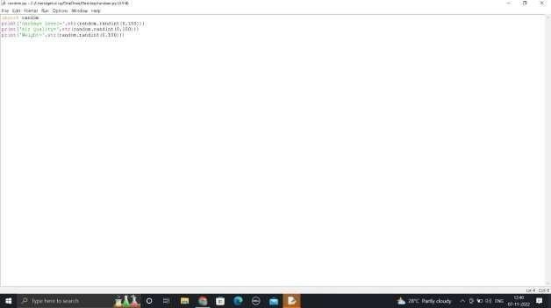

OUTPUT:

